NBEAC Accreditation Process
The NBEAC accreditation process comprises of eight stages as outlined in Fig:1 below. The illustration depicts the progression from and link between the different stages. The different stages are enumerated below and explained in the following text:
- Formal Application
- Pre Eligibility Mentorship
- Eligibility Screening
- Pre Review Mentorship
- Self-Assessment Process
- Peer Review Process
- Accreditation Decision
- Continuous Review (Reaccreditation / Accreditation)

Fig 1: NBEAC ACCREDITATION FRAMEWORK
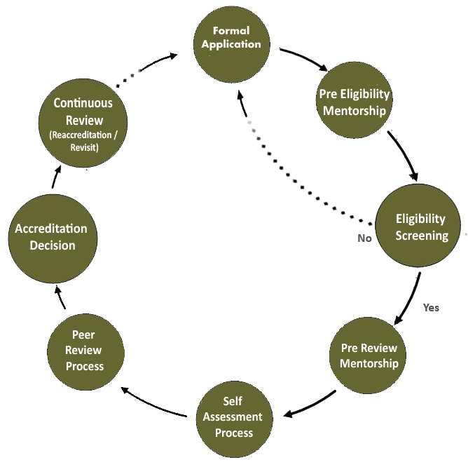

Stage 1: Formal Application
- To formally enter in the accreditation process, the business school will submit the online registration application at http://app.nbeac.org.pk/ with the registration fee of Rs.25,000/(non-refundable). The application form contains the basic information about Strategic Management, Students, Faculty, Curriculum and Linkages etc.

Stage 2: Pre Eligibility Mentorship
- NBEAC allocates mentors to provide guidance to the universities/business schools i.e. Pre Eligibility Mentorship. The role and involvement of the mentor is as per the approved policy in this regards; key features are outlined below:
  - Purpose - To address the developmental needs identified during the eligibility screening process to produce an updated registration application/datasheet .
  - Visit – During the ONE day visit, mentor interacts with the school's Director/Dean, the internal committee and the faculty and informs the minimum criteria for accreditation.
  - Post Visit – Mentor submits report to NBEAC secretariat and specifies time required for submission.
  - Involvement and support of mentor is a voluntary activity initiated at the request of the school.
Stage 3: Eligibility Screening
- The university will submit registration application to NBEAC one month before the scheduled meeting of Eligibility Screening Committee (ESC) as displayed on NBEAC Website.
- The ESC will review the registration application as per the basic eligibility screening criteria. The following criterion are pre-requisites of NBEAC revised eligibility and screening policy 2017.
- Number of graduated batches: At least 3 batches of the degree should have passed to consider the program for accreditation. For example:
- BBA becomes eligible after 5.5 years of program started
- MBA 1.5 becomes eligible after 2.5 years of program started
- MBA 2.5 becomes eligible after 3.5 years of program started
- MBA 3.5 becomes eligible after 5 years of program started
- Mission and vision statement
- Vision and mission should exist, be realistic and shared among the all stakeholders. Mission statement of business school should be clear, current and aligned with its vision statement.
- There should be documentary evidence that vision and mission are approved by any statutory body (not from individual competent authority).
- The vision and mission should be displayed on the Department's webpage. There should be synchronization between both versions i.e. presented to NBEAC and displayed on website.
  - Strategic plan
      - Strategic plan should exist and be for minimum 03-05 years
  - Faculty
      - There should be minimum of 15 full time faculty members related to management sciences/business administration field.
      - 03 faculty members at prof/associate-prof level are preferable however, minimum 02 associate professors and 03 at assistant professors are required to become eligible for accreditation process.
- Student to computer ratio and bandwidth
- Bandwidth internet service = 1 MB access rate
- Student to computer ratio = 1:20
  - Student to teacher ratio:
      - 25:1 (undergraduate) 20:1 (graduate) 1:15 at the research based (MPhil), and 1:8 at the doctorate (PhD) level.
  - Recommended course load should be:
      - Lecturer= 3-4 per semester/6-8 per annum
      - Assistant professor= 3 per semester/6 per annum
      - Associate professor/ professor=2-3 per semester/4-6 per annum
- Universities will provide complete information and will not leave any field incomplete in the application form. The application process will only move forward when all required information is provided.
- The decision of committee is communicated by NBEAC Secretariat to Business Schools through Initial Eligibility Screening (IES) letter.
- If a university does not qualify for registration, they may avail the facility of Pre Eligibility Mentorship to complete the registration process within 06 months to one years’ time period. The university shall reapply for registration without resubmitting the registration fee.
- If a university qualifies for Self-Assessment Process, the ESC shall recommend a timeline to submit Self-Assessment Report (SAR).

Stage 4: Pre Review Mentorship
- If a university feels appropriate, they may avail the facility of Pre Review Mentorship i.e. Mentor Visit. The role and involvement of the mentor is as per the approved policy in this regards; key features are outlined below:
  - Purpose - To cross check the data given in the forms and presented by the school, to identify the gaps and suggest improvements essential before submission of Self-Assessment Report (SAR).
  - Visit – During the one day visit, mentor interacts with the school's Director/Dean, the internal committee and the faculty to understand the process followed and issues /concerns of the school.
  - Post Visit – Mentor submits report to NBEAC secretariat, specifies time required for submission and recommends conduct of Peer Review Visit.
  - Involvement and support of mentor is a voluntary activity initiated at the request of the school.
  - The mentoring team is composed of 01-02 members. The mentor cannot take part in Peer Review Team (PRT) or business school team which prepares the SAR and chalks out steps for peer review and accreditation.

Stage 5: Self Assessment Process
- The self-assessment process is expected to take about 8-12 weeks (starting from issuance date of IES Letter), during which time the school is encouraged to take advice or make enquiries from NBEAC secretariat or mentor, either by phone, email or personal visits. The SAR is composed of nine proformae (downloaded from www.nbeac.org.pk or submitted through NBEAC online application: https://app.nbeac.org.pk).
- The complete report will be submitted to Secretariat along with accreditation fee (Rs.250,000 per Program) and one copy of Self-Assessment Report along with supporting documents.
- Only one copy of SAR is to be submitted for desk review at NBEAC secretariat to ensure if all documents are submitted. The remaining five copies will be submitted after receiving explicit consent from NBEAC secretariat.
- After the receipt of completed SAR along with accreditation fee, the Consultative Committee will nominate a peer review panel (that will form the PRT) on the request of NBEAC secretariat. The PRT functions through site visit of the applicant institution by an expert working group constituted for the purpose which is supported by the NBEAC Secretariat.
- The Consultative Committee constituted by NBEAC will approve the five to six member PRT by nominating the Lead Evaluator (Chairperson-PRT) and Subject Experts. PRT will be composed of five to six members. However, for re-visit (Y-Category Business Schools), the PRT is reduced to three members. Following is the composition of the PRT:
  - One member who has experience of any national/international accreditation process will assume the role of Chairperson-PRT.
  - Two members will be subject experts familiar with the relevant policies, NBEAC accreditation process and procedure having considerable experience in this field.
  - One corporate representative
  - NBEAC secretariat representative
- In case of conflict of interest, Chairman NBEAC has the authority to decide. Member (s) can also announce any conflict of interest with the institution before taking part in the peer review process. The quorum of the PRT to visit the concerned institution will be at least three out of five where presence of the Chairperson-PRT will be compulsory. The participants will also sign a statement to maintain confidentiality of the information and documents during and after completion of the visit.
- The SAR will be dispatched to the PRT for review. The secretariat will ensure that there is adequate time between receipt of self-assessment report and the date of peer review visit (usually at least 03-05 weeks).

Stage 6: Peer Review Process
- The peer review visit is ordinarily expected to be for three working days. A proposed schedule for 03-day visit is also shared with the PRT prior to the visit.
- After the formal sessions have completed, the team meets to finalize the briefing to the school on day 3. The Chairperson- PRT will present the verbal feedback of assessment process to the school. The main findings, recommendations and any critical comments are to be part of the briefing. Deficiencies will also be clearly identified along with the recommendations to the school.

Stage 7: Accreditation Decision
- The NBEAC secretariat will present the PRT report to the Accreditation Award Committee (AAC) along with their profile sheets after a thorough desk review at the secretariat level. In some cases, the secretariat may request the PRT to complete the missing sections.
- AAC makes one of the following decisions in this regard:
  - Endorse recommendation (agreement with recommendations of the PRT);
  - Provisional recommendation (approval after completing changes in the language or consistency of the report, but no changes in recommendations of the PRT); or
  - Revise recommendation (recommend changes in the language or consistency of the report and/or endorse revision in the PRT recommendations).
- The NBEAC secretariat works with Chairperson- PRT to incorporate the recommendations of AAC.
- The secretariat shares the (revised) PRT report with the institution under review in case of full or provisional recommendation.
- The interim PRT report is shared with the business school to request their feedback. Business schools could only review the factual errors.
- The feedback of business school is submitted to "Accreditation Award committee" (AAC).
- The NBEAC secretariat works on the feedback provided by the business school with respective Chairperson- PRT to make all the approved changes (by AAC).
- The Chair of AAC, on behalf of the members, approves the final report in all of the below outcomes to ensure compliance of AAC decision.
- The decision and recommendation of AAC is forwarded to the Council for endorsement. There will be four types of accreditation decisions:
  - 05 years, W{the institution receiving scores 80% or above}
  - 03 years, X{the institution receiving scores between 65%- 79% ( 65% will be raised to 70% from the year 2020 onwards)}
  - Not qualified for accreditation, Y { The institution receiving scores less than 65%}
  - Accreditation Withdrawal, if a business school assumes after reviewing the PRT report (shared with the schools before Council decision) that a negative decision is probable, the school may decide to withdraw from the accreditation process. In this case, the school can reapply for eligibility after 02 years from the date of withdrawal.

Stage 8: Continuous Improvement
The NBEAC process does not culminate on the completion of the PRT visit or accreditation. This is envisioned to be a continuous process through which the school enhances its’ quality and improves its standards before the re-accreditation visit.

